Supplementary Information
Figure 1D

Figure 2B
 | GAPDH
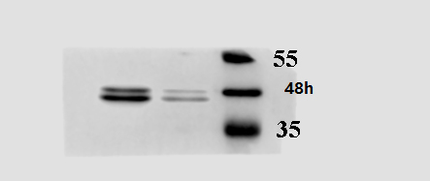 | p-ERK
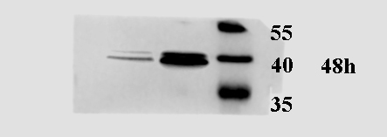 | ERK
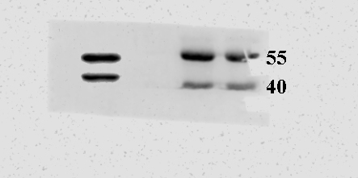 | p-JNK
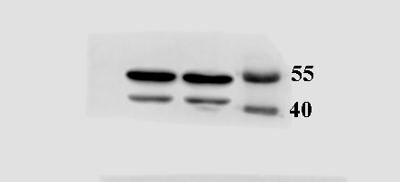 | JNK

Figure 2D-1
 | GAPDH
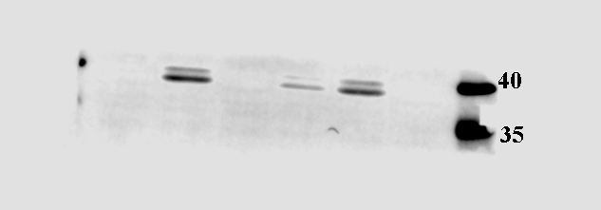 | p-ERK
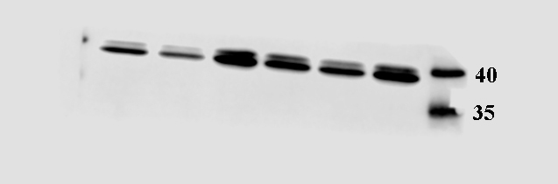 | ERK
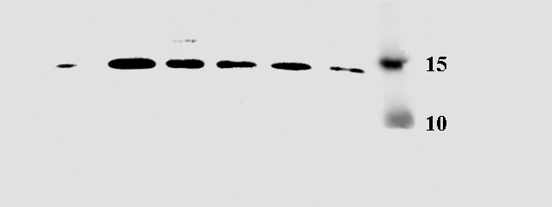 | LC3

Figure 2D-2
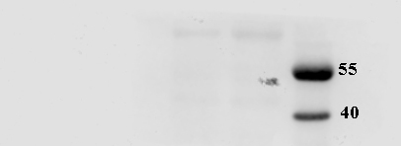 | p-JNK  Exposure for 2min
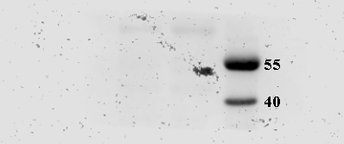 | p-JNK  Exposure for 10min
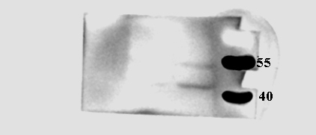 | p-JNK  Exposure for 30min

Figure 3A
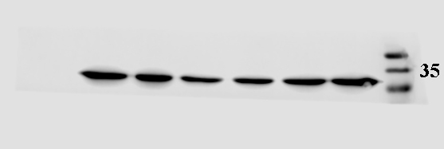 | GAPDH
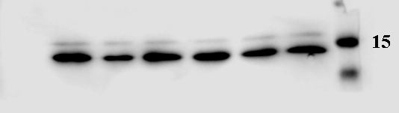 | LC3
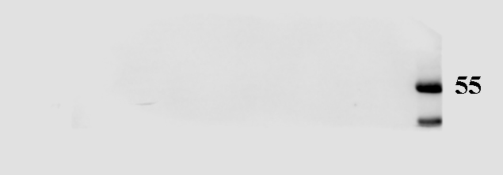 | hMPV  Exposure for 2min
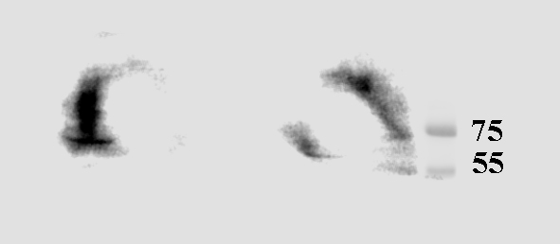 | hMPV  Exposure for 10min
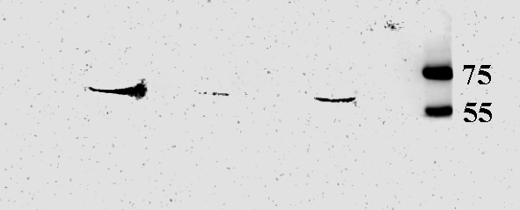 | hMPV  Exposure for 30min

Figure 4A
Figure 4C
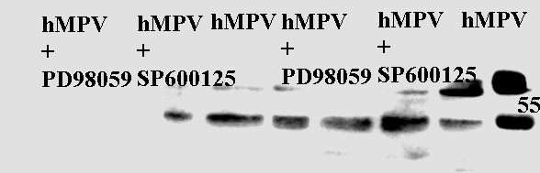 | hMPV
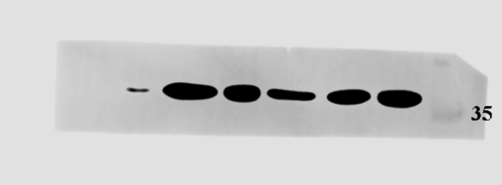 | GAPDH
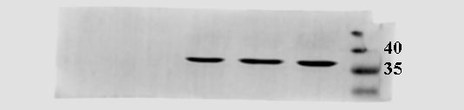 | GAPDH
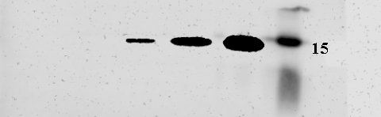 | LC3

Figure.5
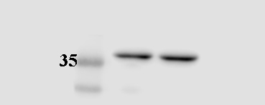 | GAPDH
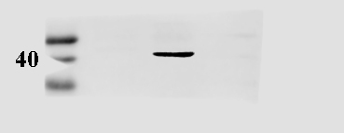 | p-ERK
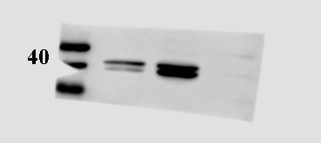 | ERK
p-JNK
Exposure for 2min
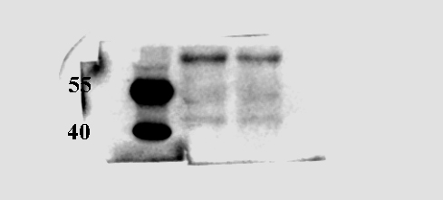 | p-JNK  Exposure for 30min
p-JNK
Exposure for 30min
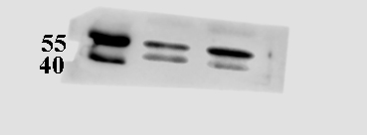 | JNK

